Quick Start Guide For Students Pearson EasyBridge
Plus

Log into LaunchPad: http://launchpad.fultonschools.org

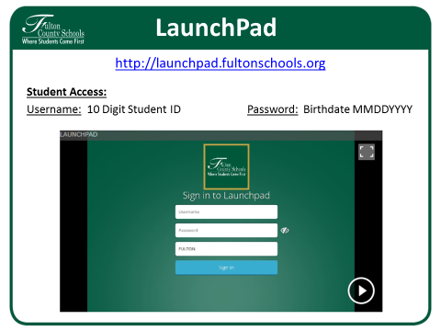

Click on the Pearson EasyBridge app on LaunchPad.

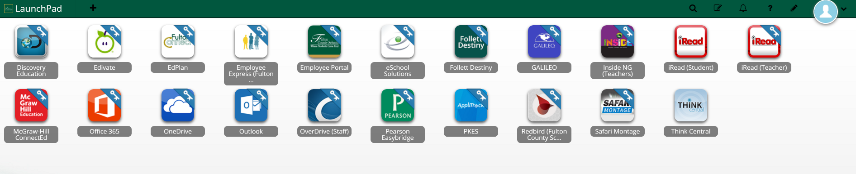

Access your Pearson Learning Platforms (Digital Books)

To access assignments and curriculum products associated with a class, follow either of the instructions below:

- Click on the arrow next to the course name and select the curriculum, or
- Click the platform name on the right side of the screen under Learning systems.

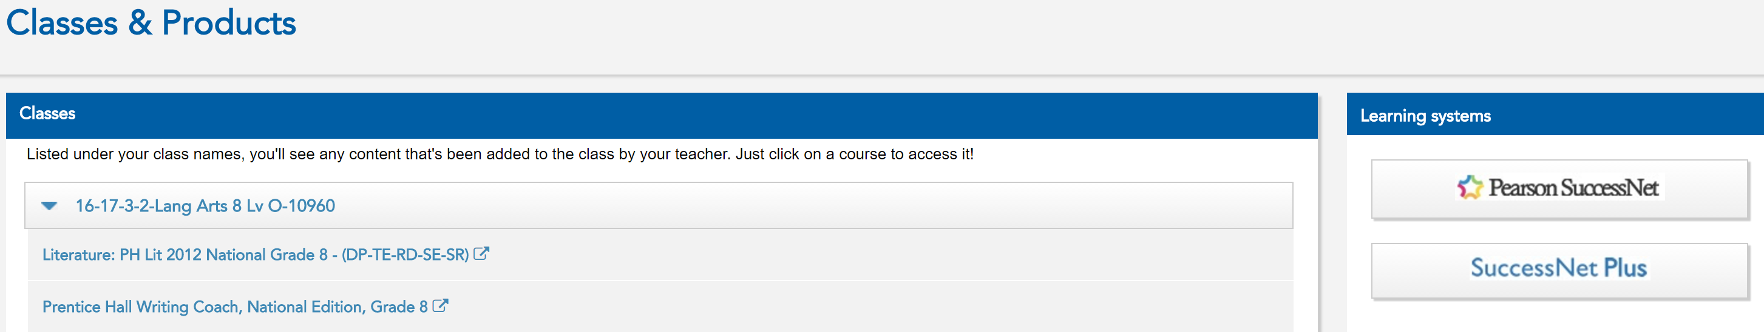

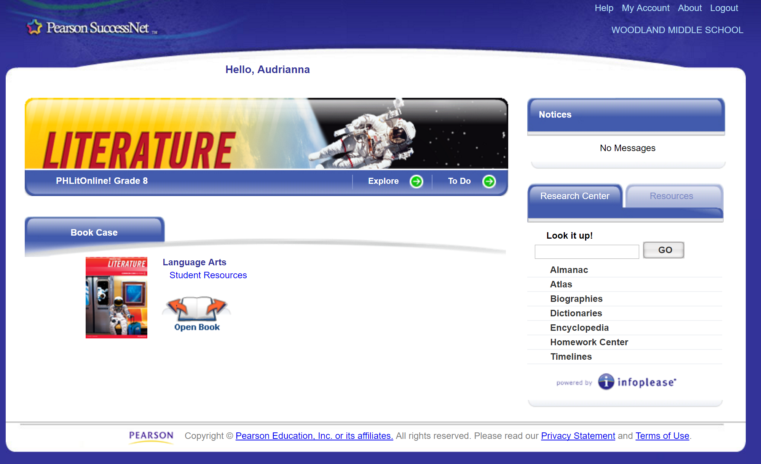

Sign Out

Students only need to sign out of one application, including EasyBridge, Pearson SuccessNet, or SuccessNet Plus, Pearson Realize.When logged out of one application, you will be redirected to a page letting you know you have successfully signed out of all of your integrated Pearson learning platforms.

Note: Signing out incorrectly can cause a session to become locked, preventing access with your next login attempt. If this occurs, clear your browser cache and close the browser window. Try logging in again. If the problem persists, contact your teacher.

https://pearsonnacommunity.force.com/coco/s/EasyBridge

Additional Resources

Access training guides and other information about Pearson EasyBridge at:

